

**Mortgages and housing in the near and long term**

Speech given by

David Miles, External Member of the Monetary Policy Committee, Bank of England

At the Home Builders Federation Policy Conference, London 31 March 2011

I would like to thank Jochen Schanz and Gilberto Marcheggiano for research assistance and others for helpful comments. The views expressed are my own and do not necessarily reflect those of the Bank of England or other members of the

Monetary Policy Committee.

We have been through an exceptionally severe recession – output has fallen very sharply and unemployment has risen a great deal. Confidence about the standard of living we might expect for our future selves and our children has been shaken. Such events will always be likely to affect the value of long lived assets and few assets have as long to live as houses. Willingness and ability to buy them will be hit by falls in incomes and by greater uncertainty about the future. This will affect lending and house-building. But the impact on the housing and mortgage markets over the past few years has been greater than is usual even in a bad recession – even a recession that has been as deep as we have seen. And that is because this recession started with the near collapse of the banking system. The level of net mortgage lending has fallen to a small fraction of the average for the 5 years leading up to the start of the crisis in 2007. The number of transactions in the housing market is running at about half the levels of 2002-2007. Numbers of housing starts have also about halved since the start of the crisis. Average UK house prices, in real terms, are about 20% below the levels of mid 2007. Thankfully – and unlike in the USA – re-possessions of property and arrears on mortgages have not picked up dramatically.

# Chart 1 – Monthly number of houses sold

160

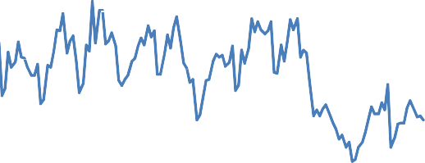

thousands

140

120

100

80

60

# Chart 2 – Number of housing starts

250

thousands

200

150

100

40

20

0

2000 2001 2002 2003 2004 2005 2006 2007 2008 2009 2010

50

0

2000-01 2002-03 2004-05 2006-07 2008-09

*Source: HM Land Registry*

# Chart 3 – Real house prices1

250

£ thousands

200

150

*Source: DCLG*

# Chart 4 – Net flow of mortgage lending

12,000

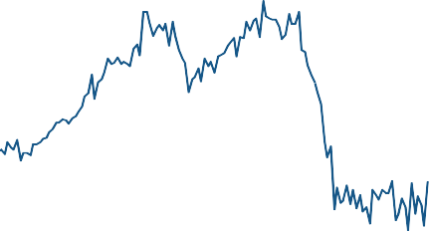

£ millions

10,000

8,000

6,000

100

4,000

2,000

50

0

0

2000 2001 2002 2003 2004 2005 2006 2007 2008 2009 2010

*Source: Nationwide*

-2,000

2000 2001 2002 2003 2004 2005 2006 2007 2008 2009 2010 2011

*Source: Bank of England*

I want to explore how persistent the fall in activity in the housing market – and for transactions and lending it has been a dramatic fall – might be. There are two views I want to consider. The first is that what we are

1 Average nominal house prices deflated using the ONS Retail Price Index (RPI).

seeing is a painful transition from a position where the cost and availability of mortgage debt was unsustainable (and may have fuelled unsustainable expectations about house price rises) to a more sustainable position. On that transition activity – in terms of lending, housing transactions and

house-building – will be very sharply lower. But the transition does not last decades, though it may take some years. The second view is that we may be stuck in a bad equilibrium of low confidence, low willingness to lend which is unwarranted by the risks, and impaired ability to buy; and that we cannot be confident that these things will self-correct. Neither of these hypotheses suggests things will be easy – but the first is less bad. On the first view, it is as though we have bad toothache but at least we are in the dentist’s waiting room. It is not a nice place to be, but we will not be here for too long. On the second, we have bad toothache and there is no dentist in sight.

Let me say at the outset that I believe the evidence is more consistent with the first – the less bad – of these interpretations. That does not mean that the situation is easy since the transition is difficult – as can be visits to the dentist – and its length is measured in years rather than months (as I shall try to calibrate). And even when the transition is over it poses policy problems – one of which (though not necessarily the most serious one) affects monetary policy. Since monetary policy is what I do it is an issue which I will say something about later.

To assess how much of what we are seeing in the housing and mortgage market is a transition from an unsustainable position to something more sustainable we need to start by looking at where we were before the financial crisis. Let me begin with the cost and availability of mortgage debt, because I believe that is where the un-sustainability was most evident and it is the move towards a more durable structure of mortgage supply that drives most of the adjustments we are seeing.

Chart 5 shows a measure of the cost of mortgage funding, and of the average interest rate on one of the most common forms of variable rate mortgage, over the period since the late 1990’s. The cost is a weighted average of the interest rates (or yields) on sources of funds for the major mortgage lenders. The quoted spread on new mortgage lending – that is the difference between a measure of the cost of funds and the interest rate charged on new lending on tracker mortgages – declined fairly steadily between 2000 and the onset of the crisis. At the end of the 1990’s that spread was around 2% to 2.5% (Chart 6). This spread needed to cover the cost of running some substantial part of the institution and in particular the non interest rate cost of gathering funds (which for many lenders included a substantial part of the cost of running a branch network). It also needed to cover expected bad debts and generate a risk adjusted return on capital in excess of the cost of debt. That spread seems to have fallen gradually over the course of the period from 2000 to 2007. By the middle of 2007 it had fallen to 150bps – more than 30% below the average spread over 1998-2000.

# Chart 5: An estimate of the debt funding costs of UK banks2

7

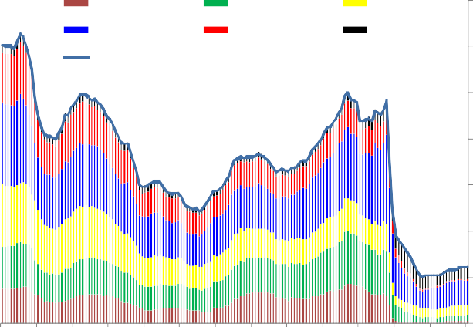

HHD sight

0FC+PNFC sight

HHD Time

%

PNFC+OFC Time

CDs & CP

bonds

WACC

6

5

4

3

2

1

0

1998 1999 2000 2001 2002 2003 2004 2005 2006 2007 2008 2009 2010 2011

# Chart 6 – Spread of quoted tracker mortgages over reference rates

3.5

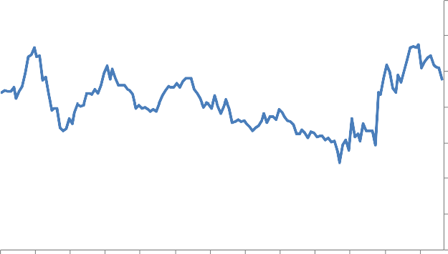

%

3

2.5

2

1.5

1

0.5

0

1998 1999 2000 2001 2002 2003 2004 2005 2006 2007 2008 2009 2010

*Source: Bank of England and own calculation*

The charts focus on the average spread. Given the very different risks (to the lender) of different types of loan one might have expected the spreads to vary rather a lot between different types of mortgage – that is between mortgages with different loan to value ratios and those made to borrowers with different degrees of variability in incomes and evidence on those incomes. What is remarkable in the years leading up to 2007 is how little variability there was. For example, in early 2007 rates charged on mortgages with very different loan to value ratios differed by very small amounts – and by much less than is the case today (Chart 7).

2 I assume that banks’ funding cost is a weighted average of the cost of several types of debt: sight deposits by households; sight deposits by private non-financial corporations (PNFC) and other financial corporations (OFC); time deposits by households; time deposits by PNFCs and OFCs; certificate of deposits and commercial paper; longer-term bonds. The weights for these different sources of funding reflect their relative size on MFIs balance sheet. I approximate the cost of each funding source by using the following interest rates series: Bank of England data on households interest bearing sight deposits; 3-month Libor for sight deposits by PNFCs and OFCs; Bank of England data on time deposits by households; 1-year Libor for time deposits by PNFCs and OFCs; 3-month Libor for CDs and commercial paper; the yield on the Markit iBoxx Sterling Bank Senior Bond index for longer-dated bonds.

# Chart 7 – Quoted interest rates on two-year fixed-rate mortgages(a)

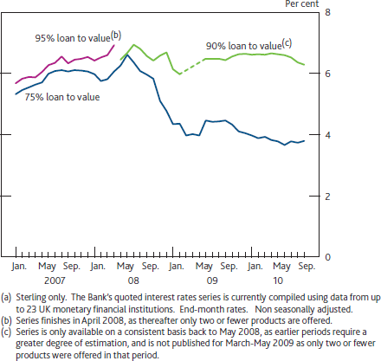

In the years leading up to the crisis the average spreads on new loans were falling as the quality of information on new borrowers’ incomes was almost certainly declining. And at the same time typical loan to income ratios of new borrowers were rising fast (Chart 8). Prior to the crisis lending standards had been relaxed very significantly. The FSA estimates that in 2007/08, for about 50% of mortgages, income was not verified, up from 28% in 2005. This means that a significant proportion of borrowers may have been effectively self-certifying their income.

I believe it is very hard to avoid the conclusion that by 2007 – and for some years before that – the pricing of different mortgages did not bear much relation to risk. And for new mortgage lending the spread of the interest rate over the cost of funds had been squeezed substantially relative to levels of the late 1990’s even as the average riskiness of new lending moved higher. Both the average spread on new mortgage lending and the variability in spreads across different types of mortgage looked unsustainable.

# Chart 8 – Median LTI ratio for First-time Buyers

3.5

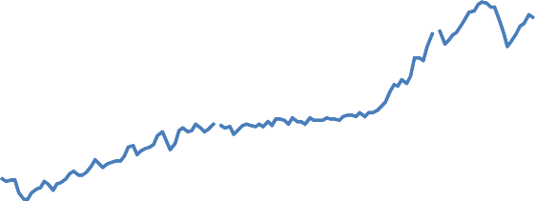

3.0

2.5

2.0

1.5

1.0

79 80 81 83 84 85 87 88 89 91 92 93 95 96 97 99 00 01 03 04 05 07 08 09

*Source: CML*

The failure of pricing to reflect risk differences is something I focused on in the Mortgage Review I undertook in 2003 and 2004.3 I felt then that it was a problem and that it was undesirable that existing borrowers with low loan to value ratios and who had a track record of servicing loans often paid much higher rates than those with large loans, relative to their incomes and to the value of their homes, and who often also had no track record of paying debt and sometimes limited proof of income.

The failure of spreads on new loans to reflect risk and to generate an adequate risk-adjusted rate of return to providers of funds is something you could get away with for a while – a degree of cross subsidisation from the back book of mortgages helped keep it going. But eventually you run out of road – in terms of cross subsidisation from the back book you run out of suckers. Maybe it could have carried on for a few more years. But the financial crisis came along to put a stop to it. Since then we have had a very sharp move in the pattern of risk pricing and credit availability.

The spreads on new mortgage lending now have two features: the average spread over a measure of the cost of funds is substantially higher than in the years leading up to the crisis; it has moved back to a level that is closer to the level at the end of the 1990s. Indeed that spread may now be a bit above the pre 2000 average – though probably not by much. Differences in mortgage spreads *between* new mortgages of different types today also look much more consistent with likely differences in risk. There are now substantial differentials between interest rates on mortgages with different risk characteristics

(Charts 9 and 10). I want to re-iterate just how much of a change this is from the period before the crisis. It is not just that such differentials did not exist before the crisis. They were actually perverse – mortgages with higher risk (e.g. new loans at high LTV made to those with limited proof of income and for whom loans relative to reported incomes were high) very often had a lower interest rate than that charged to existing borrowers who had been paying their mortgage on time and in full for years and whose mortgage balance relative to both their actual income and to the value of their home was low.

The availability of mortgages with very high loan to value ratios has also fallen sharply, so it is not just a case of the price of such mortgages having risen relative to mortgages where the loan is smaller as a proportion of the value of the house. The lack of availability now of loans that are close to 100% of house value is clear (Chart 9). But it should not – I think – be seen as a sign of a damaged market, one that is not functioning properly. It probably never made sense for there to be 100% mortgages. There may be no price at which it makes commercial sense for such a loan to be available – a point made thirty years ago by Stiglitz and Weiss4.

3 Miles (2004), *The UK Mortgage Market: Taking a Longer-Term View. Final Report and Recommendations.* Her Majesty’s Treasury. Available at*:* http://webarchive.nationalarchives.gov.uk/2010040701[0852/http://](http://www.hm-treasury.gov.uk/consult_miles_index.htm)www.[hm-treasu](http://www.hm-treasury.gov.uk/consult_miles_index.htm)r[y.gov.uk/consult_miles_index.htm](http://www.hm-treasury.gov.uk/consult_miles_index.htm)

4 “Credit Rationing in Markets with Imperfect Information”, American Economic Review, vol 71, 1981

# Chart 9 – Number of mortgage products available by loan to value ratio(a)

2,000

1,800

1,600

# Chart 10 – Floating rate mortgage spreads and product availability across LTV ratios5,6

6

**Feb-11**

**Aug-08**

**Aug-09**

**Feb-11**

**Aug-08**

**Aug-09**

**Feb-11**

**Aug-08**

**Aug-09**

**Feb-11**

**Aug-08**

**Aug-09**

**Aug-08**

**Aug-09**

**Aug-08**

**Aug-09**

**Aug-08**

**Aug-09**



**Aug-08 Aug-09 Feb-11**

%

5

1,400

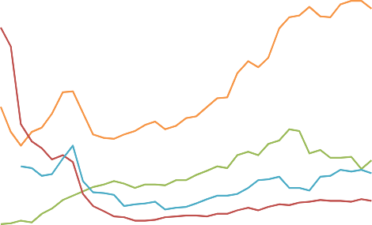

75-89% loan to value

90% + loa n to va lue

0-74% loan to value

Buy to let

4

1,200

1,000 3

800

600 2

400

200 1

0

Feb Jun Oct Feb Jun Oct Feb Jun Oct Feb 0

2008 2009 2010 2011

*Source: Moneyfacts Group and Bank calculations (a): Sterling only. Excludes self-certified mortgages.*

55 65 75 85 95

Loan to value ratio (per cent)

*Source: Moneyfacts and Bank calculations*

# The Transition back to reality..

What is the impact of going (back) to a world where the pricing and the availability (or lack of it) of high LTV mortgages looks to be more sustainable?

A simple back of the envelope calculation can be very helpful here – one using figures that are not wholly unrealistic. I want to use such a calculation to illustrate the impact of requiring higher deposits of new home owners. Imagine that initially people can buy a house with a 5% deposit. Assume that a house for a

first-time buyer costs 4 times their annual income. So they need to get a deposit that is 20% of annual income. That is a substantial sum and one which with a saving rate of 5% takes about four years to accumulate from the point at which you start saving7. Suppose as a potential first time buyer you are in a position to start doing that at age 28, so typically you buy at age 32. Now assume that – suddenly – the deposit needs to be 10%. That means a potential first-time buyer needs to have a deposit worth 40% of annual income and this requires 8 years of saving at a rate of 5%. Other things equal this means the typical age of a first time buyer rises to 36. The transition from one equilibrium to another – assuming the requirement for a higher deposit is sudden and unexpected – is stark. In the stylised example, for about four years after the sudden shift in the required deposit no first-time buyers can enter the market. But after that the flow of new first-time buyers goes back to its normal level.

5 End-month advertised rates for products with different LTV ratios.

6 The size of the bubble reflects product availability. The spread is calculated over Bank Rate at the end-month for the relevant period.

The first observation on the left is for products up to 65% LTV, the second is for products in the 66-75% range, the third is for products in the 76-85% range and the final observation on the right is for products above 86%.

7 The payment of interest on savings, the growth in incomes and changes in house prices during the period of saving mean the answer is not exactly four years.

The level of owner occupation, however, is likely to be permanently lower. Assume we have a constant population. People leave home at age 20 to rent. Before the rise in required deposits they start saving at 28 and buy at 32 and then stay in owner occupation until, say, age 75. Everyone (sadly) then moves back into the non-owner occupied sector for the last 5 years of an 80 year life. In this stylised version of the UK the proportion of adults (that is people aged 20 to 80) who are owner occupiers is then:

(75-32) / (80-20) = 43/60 = 71%

When the required deposit goes to 10%, so the age at which people buy their first home becomes 36, the new equilibrium owner occupation rate is:

(75-36) / (80-20) = 39/60 = 65%

The chart below illustrates this transition. The green line shows the evolution of the number of house purchases by first-time buyers; the red, dashed, line is the owner occupation rate.

# Chart 11 – Impact of lower LTV ratios: a stylised model

Owner occupation rate

71%

65%

Number of house

purchases by first-timers

4 years

How does this model compare to real data? The UK owner occupation rate was near 70% in 2006; it has since moved down to 67%. Over the same time, the number of loans granted to first-time buyers has about halved. The fact that this number has not fallen more, as the stylised model would predict, can probably in part be explained by additional assistance that has been given to first-time buyers, for example in the form of shared equity schemes or help from parents. Indeed, the CML estimates that the share of first-time buyers

under 30 who received some form of assistance about doubled from about 40% to just over 80% (Table 1).8 It is notable that not only have transactions by first-time buyers fallen sharply – loans to home movers are also down sharply. I believe this reflects the importance of first-time buyers in allowing chains of transactions to be feasible.

# Chart 12: Number of loans to first-time buyers and home movers9

**Chart 13: Share of owner-occupied housing**

Thousands 80

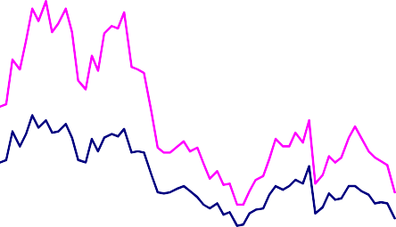

Home movers

First-time buyers

70

75%

60

70%

50

65%

40

30

20

10

0

2006 2007 2008 2009 2010 2011

80 82 84 86 88 90 92 94 96 98 00 02 04 06 08 10

60%

55%

50%

*Source: CML*

*Source: English Housing Survey 2009/2010*

# Table 1: Proportion of assisted FTBs

*Source: CML*

A lower owner occupation rate does not imply a loss in wealth or a fall in the standard of living. Across countries there is not a positive correlation between average standards of living and rates of owner occupation – if anything across the world as a whole there is a negative correlation. So a move lower in the rate of owner occupation is not in itself something we should necessarily worry about. But a collapse in

first-time buyers is not so easy to live with – and the stylised example shows that after an unexpected rise in the required deposit there is not a gradual decline in first-time buyers but instead a collapse. But it is a collapse followed some years later by a return to the old level. The demand for property is not so volatile because people do need to live somewhere – in the stylised example above there is a net increase in the

8 Source: Council of Mortgage Lenders, ‘Problems for first-time buyers, News and Views no 3, 15 February 2011.

9 First-time buyers will include some buyers who have previously owned a property, but are not in owner-occupation at the time of this purchase. Estimates from the CML suggest that around 20% of stated first-time buyers may in fact fall into this category.

demand for renting and that builds up year by year over the transition. It is reflected by the rising rental stock – the flip side of the falling owner occupation rate in the figure. In the real world many people suddenly faced with the prospect of having to save for longer to become owner-occupiers may live at home longer, so the offset of bigger demand for (new) rental properties against lower demand for owner-occupied property is not complete. And for builders of new houses that is extremely difficult.

I think the stylised calculations suggest that a very big fall in first-time buyers, much lower transactions, and much lower new mortgage lending are what you would expect in a transition from one equilibrium to another. And where we started from in the UK was neither desirable nor sustainable (in terms of pricing and type of mortgage loans). The transition is not likely to be as smooth as the stylised example suggests. There may be a degree of overshooting – maybe the “right” deposit needed to go from an average of 5% to 10% and maybe we have gone from 5% to 15%; and perhaps risk pricing will overshoot. Neither of those things is obvious, but they may have happened. But I think the bigger point is this: even a smooth transition to a more sustainable, efficient and fair pricing of mortgages would – given where we started from – likely have lead to big falls in lending, many fewer first-time buyers and much reduced housing transactions during an extended transition. In the stylised example it is a transition that lasts 4 years. This is why I think the first of the two hypotheses I described at the outset – the one that saw the recent outcomes as largely reflecting a difficult transition rather than a broken machine – is the more likely. Since we can explain the big falls in activity as being consistent with the transition story we don’t really need to invoke the “it’s a broken machine” (i.e. bad equilibrium) explanation. That second interpretation of events is, it seems to me, a suitable victim for Occam’s razor – a simpler explanation explains the facts.

# Chart 14: Median LTV ratio of first-time buyers10

Per cent

100

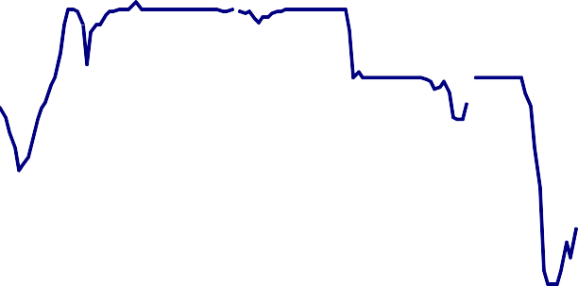

95

90

85

80

75

70

79 81 83 85 87 89 91 93 95 97 99 01 03 05 07 09

*Source: CML*

10 The vertical dashed lines represent breaks in the series.

One piece of evidence that what we are seeing in the UK housing market is transitional (and is seen by existing home owners as transitional) – rather than a permanently new state of very sharply lower transactions and permanently reduced first-time buyers – is what has happened to house prices. They have not fallen by 50% or 60%. In nominal terms average UK house prices are down about 10% from mid 2007; in real terms they are about 20% lower. If housing demand were thought to be permanently down by as much as the decline in first-time buyers since 2007 I should expect the fall in house prices to have been far, far greater.

# The new equilibrium

The transition to a new equilibrium in the housing and mortgage market is not easy. Are there also problems in a new steady state? There may be, but a lower owner occupation is not one of them and it does not mean there must be a lower demand for housing. Pricing of mortgages will be different from what had become usual in the years immediately before 2007. Some people will pay more for mortgages; but some will pay less – recall that one of the bad aspects of where we were that there was perverse cross subsidisation in the mortgage market.

It is also likely that the average spread between the interest rate on mortgages and a reference rate like Bank Rate will be different – and quite likely higher than it was just before the crisis. That does create an issue for the MPC. We need to re-calibrate the link between Bank Rate and the cost of debt to finance house purchase. In principle this is not a great problem. In practice such calibration is tricky and that spread between the rate we on the MPC set and the average cost of mortgage debt is likely to take time to change. So it is not a simple, one-off re-calibration.

There may also be a shift in the type of mortgage debt as a result of persistent – maybe permanent – changes in the scope to fund mortgages in certain ways. Since 2007 the issuance of residential mortgage backed securities (RMBS) in private markets has collapsed. In the past RMBS tended to be relatively short-dated instruments and paid rates that were often variable. They were often issued in foreign currencies because natural buyers were not UK institutions with an appetite for sterling-denominated instruments. Those who had previously bought RMBS in large quantities exited the market as the crisis unfolded. Maybe they will return. But if one stands back from the drama of the crisis and asks whether the

type of RMBS that were issued are a natural funding vehicle for UK mortgages there are reasons to question that. Mortgages take many years to pay off – even if people move house they generally need to take debt with them so it is usual for people to have substantial mortgage debt for decades. UK households – who overwhelmingly receive income in sterling – naturally want sterling mortgages. If people want long-term, sterling-denominated loans then one would expect that the natural source of funds would be from investors who want long-term, sterling assets. But the buyers of RMBS often wanted short-duration, non-sterling denominated assets and they wanted the option of withdrawing from the market – getting their money back from lenders-quite quickly. When that option was exercised (i.e. when RMBS issuance to replace maturing

issues dried up) it caused major problems with which we are still living. A more natural source of funds for UK mortgages might be from institutions who want long-term, sterling assets – for example pension funds and insurance companies. But they may also want fixed rate instruments.

Market forces can be expected to work to bridge gaps between potential suppliers and potential demanders of products and this may work in the mortgage market now to cause an evolution in the type of mortgages so that the nature of the funding and the essential nature of the debt it allows to be created are better matched.

We need a means of financing mortgages which generates secure and reliable funding. The natural providers of such funding are investors that want to hold sterling assets for long periods. Households have a substantial demand for direct holdings of such assets which is why many lenders finance a large proportion of lending from raising retail deposits. As noted above, a natural source of intermediated demand should be from long-only, institutional investors – pension funds and insurance companies. But in recent years the business model of most mortgage lenders meant that they did not generate mortgages with the degree of predictability of cash flows suited to creating longer duration securities. That was a particular business model built around creating variable-rate mortgages, often with teaser rates, sold in an environment where mortgage brokers facilitated huge amounts of churn and re-mortgaging. This generated cash flow uncertainty which precluded creating longer duration securitisations. And the RMBS that were issued often needed a good deal of financial engineering even to create short duration securities that appealed largely to overseas investors. That world has gone. We should neither expect, nor want, it to return.

It is not at all clear how this will play out and over what horizon. As it plays out the link between the decisions the MPC make each month on Bank Rate and the impact on the economy will change. In the longer run it is not clear it makes life more difficult. But today we are still in the middle of a transition and it is a difficult one. In the mortgage market it may look like we have taken many steps back. I think that is too pessimistic. I believe it is more likely that we are taking some difficult steps forward.

# Table 2: Major UK banks’ RMBS issuance in public markets (£bn)

2006 2007 2008 2009 2010 2011

Amount of RMBS issued in public markets **111.5 71.7 3.6 4.7 22.1 2.3**

*Source: Dealogic.*